Backing up emails in Thunderbird

Add the extension ImportExportTools to Thunderbird
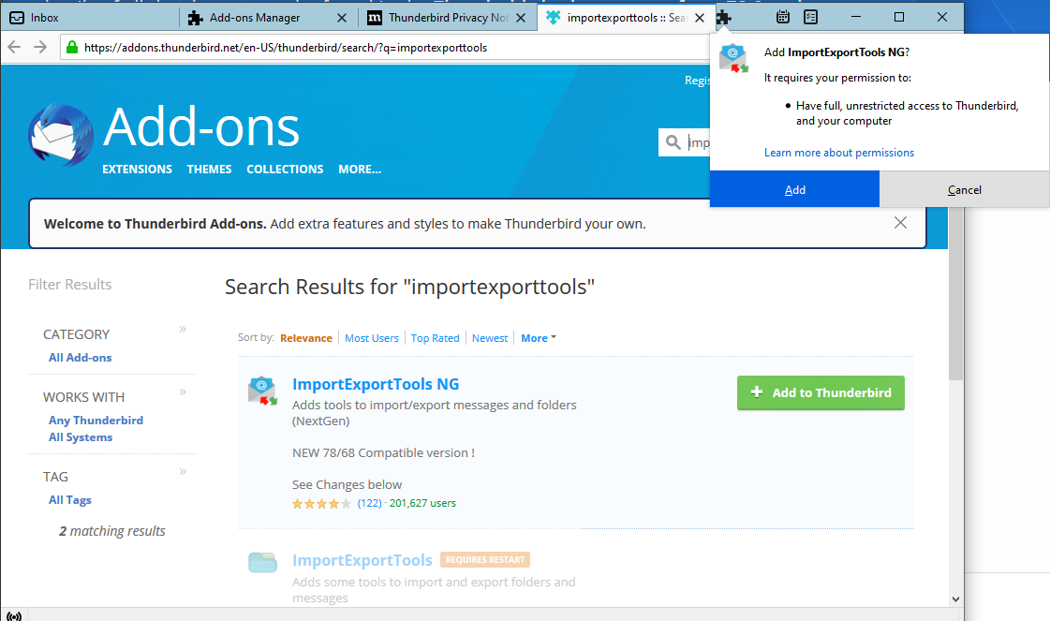
Once installed, find the folder you want to export (eg Inbox) and RIGHT-click on it
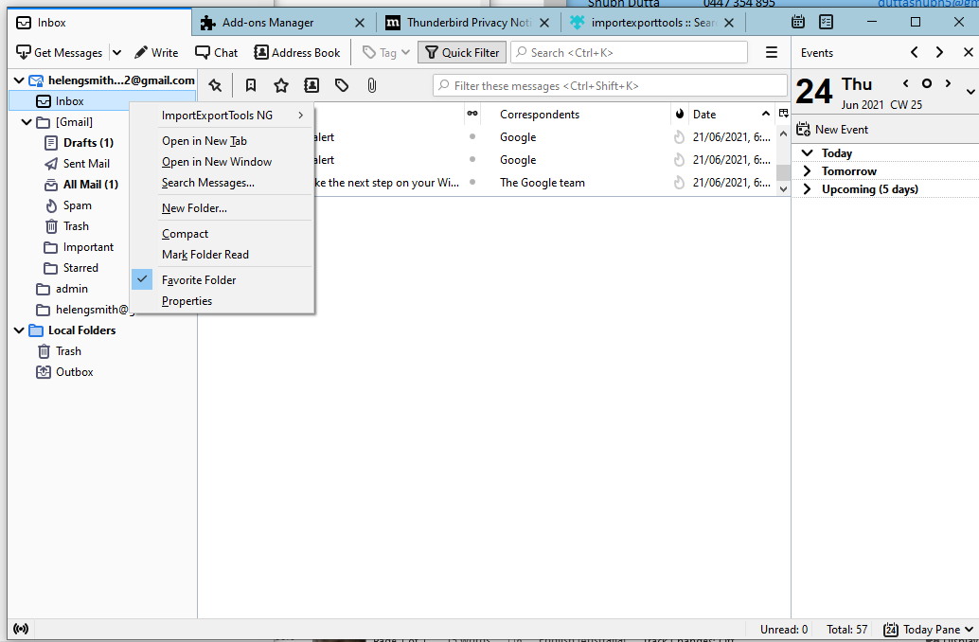
In the pop-out menus that appear, choose ‘HTML format with attachments’
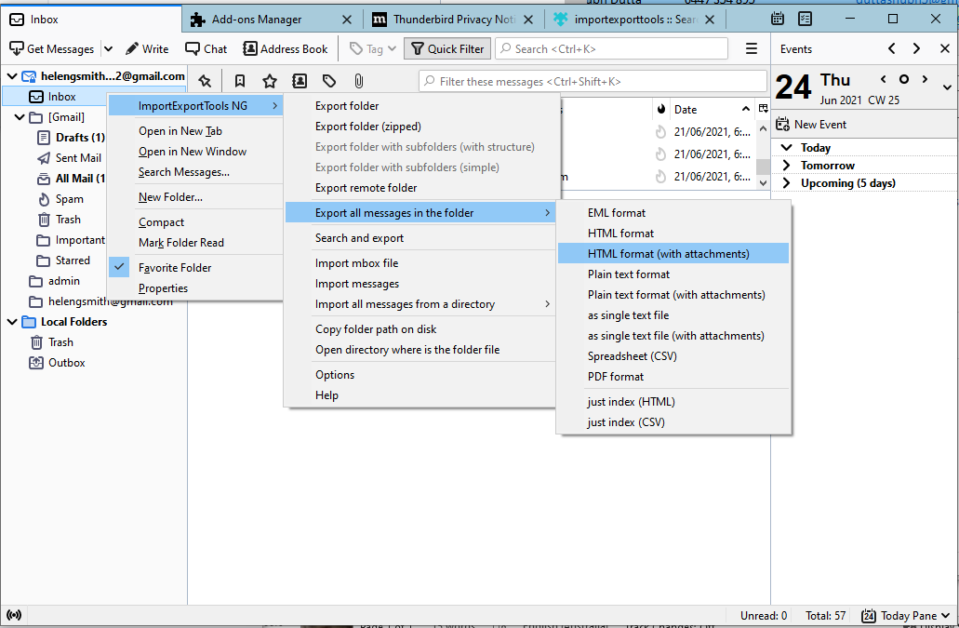
You will need to choose a folder to save these to.

This format is fine for reading in Windows but will not import to another email program.
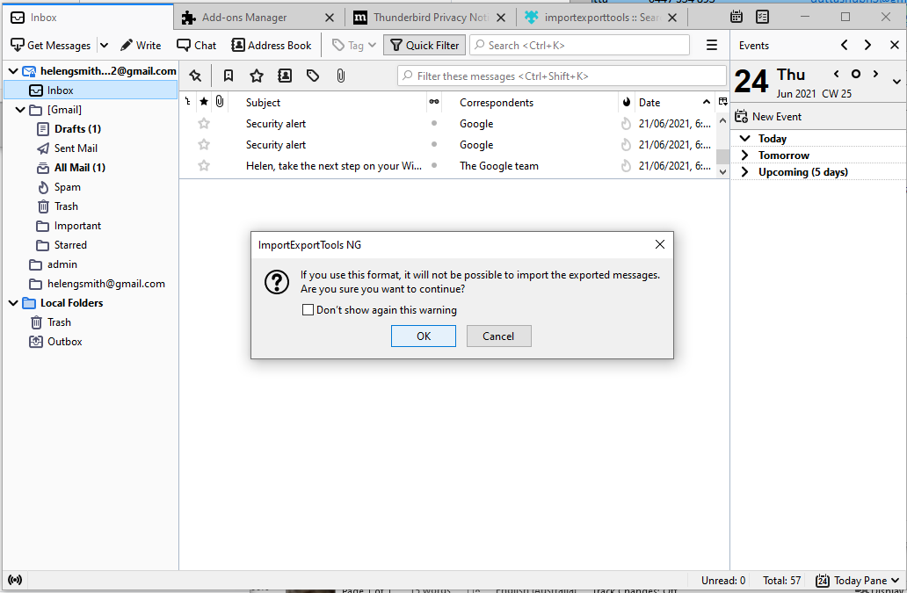
You can also use Thunderbird’s Synchronisation settings to save all your messages in local (offline) folders. This has effectively backed up your emails.
